Project Design Phase-II
Data Flow Diagram & User Stories

Date | 30 September 2026
Team ID | SWTID-2026-1362
Project Name | Weather Forecasting & Alert System
Maximum Marks | 4 Marks

Data Flow Diagrams:
A Data Flow Diagram (DFD) is a traditional visual representation of the information flows within a system. A neat and clear DFD can depict the right amount of the system requirement graphically. It shows how data enters and leaves the system, what changes the information, and where data is stored.

Example: (Weather App Flow)

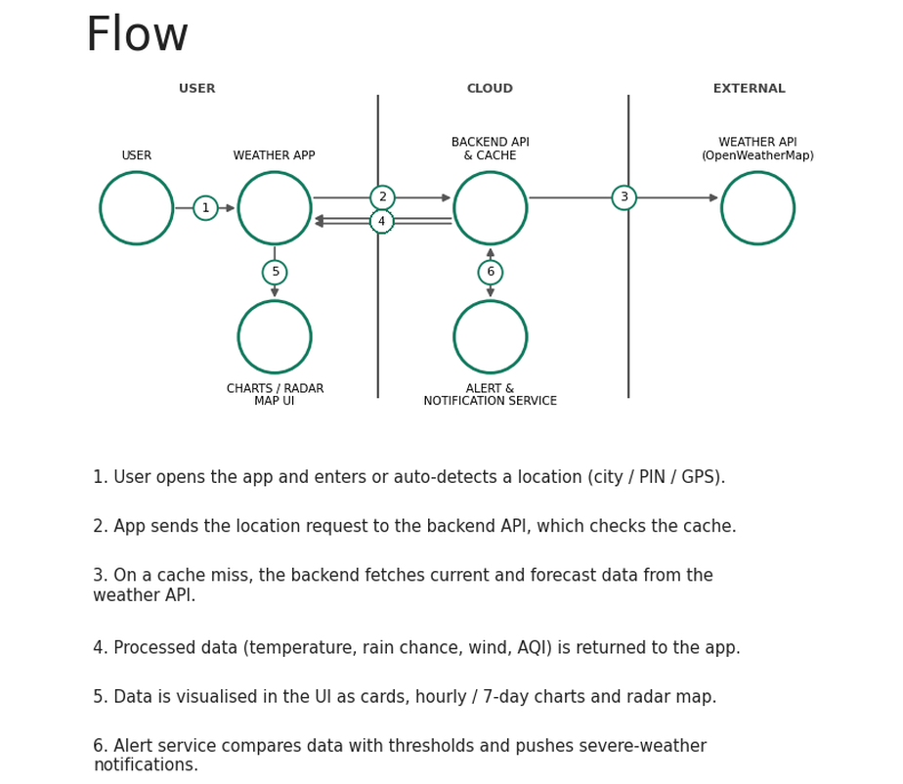

User Stories
Use the below template to list all the user stories for the product.
User Type | Functional Requirement (Epic) | User Story Number | User Story / Task | Acceptance criteria | Priority | Release
Customer (Mobile user) | Registration | USN-1 | As a user, I can register for the application by entering my email, password, and confirming my password. | I can access my account / dashboard | High | Sprint-1
 |  | USN-2 | As a user, I will receive a confirmation email once I have registered for the application. | I can receive the confirmation email & click confirm | High | Sprint-1
 |  | USN-3 | As a user, I can register for the application through Facebook. | I can register & access the dashboard with Facebook Login | Low | Sprint-2
 |  | USN-4 | As a user, I can register for the application through Gmail. | I can register & access the dashboard with Gmail Login | Medium | Sprint-1
 | Login | USN-5 | As a user, I can log into the application by entering email & password. | I can log in and see my saved locations | High | Sprint-1
 | Dashboard | USN-6 | As a user, I can see the current weather (temperature, humidity, wind, condition) of my location on the dashboard. | Current weather loads within 2 seconds for my GPS / searched location | High | Sprint-1
 | Location Management | USN-7 | As a user, I can search for a city or PIN code and save it as a favourite location. | Saved locations appear on my dashboard and can be removed | High | Sprint-1
 | Weather Forecast | USN-8 | As a user, I can view the hourly (24 hours) and 7-day forecast, including chance of rain. | Forecast is shown as cards / charts for the selected location | High | Sprint-2
 | Weather Alerts | USN-9 | As a user, I receive push notifications for severe weather (heavy rain, storm, heat wave) in my saved locations. | Alert is received within 5 minutes of being issued | High | Sprint-2
 | Air Quality | USN-10 | As a user, I can check the Air Quality Index (AQI) and get health advice. | AQI value, category and advice are displayed | Medium | Sprint-3
Customer (Web user) | Weather Maps | USN-11 | As a web user, I can view rain / temperature / wind radar maps for my region. | Interactive map loads with selectable layers | Medium | Sprint-3
 | Historical Data | USN-12 | As a web user, I can view past weather data by date and download it as PDF / CSV. | Report downloads with correct date-wise data | Low | Sprint-3
Customer Care Executive | Support | USN-13 | As a customer care executive, I can view a user's query and reported weather issues and respond to them. | Query status changes to 'Resolved' after reply | Medium | Sprint-3
Administrator | Administration | USN-14 | As an administrator, I can manage users, weather API keys and monitor data feed and alert logs. | Admin can activate / deactivate users and see API status | High | Sprint-2

